Guidance Class Lesson for the week of April 13– April 17 from Mrs. German

Hello Amazing 2nd graders and families!

This week, we will be learning about ways we can be kind to our Earth. Earth Day is April 22nd!



1. Read the book, “Mrs. Fox’s class is going Green” from YouTube. [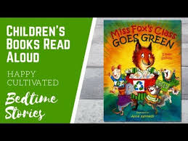](http://www.viewpure.com/R-UNKPdwpTg?start=0&end=0)
2. Click here to print the activity sheet to do at home. You can also use a blank piece of paper if you don’t want to print this. You can hang this sheet up in your house to share with your family. Like to print poster [HERE](https://www.leonschools.net/cms/lib/FL01903265/Centricity/Domain/4682/My%20AmaZing%20Earth%20Day%20Poster.pdf)

If this link does not work, I’ve put another link on the webpage.

1. Here are two more videos to watch about caring for our Earth.

YouTube: [Science Video for Kids: How to Care for the Environment](http://www.viewpure.com/V0lQ3ljjl40?start=0&end=0)

YouTube: [Curious Kids: It’s Earth Day](http://www.viewpure.com/Hxv0LX__rdg?start=0&end=0)